**Unit 3 I’m more outgoing than my sister.**

**教学目标与要求**

**话题：**人的个性特征 (Personal traits)

**功能：**1能谈论人的个性特征 (Talk about personal traits)

A: Is Tara more outgoing than Tina?

B: No, she isn't. Tina is more outgoing than Tara.

2能简单比较人物特征 (Compare people)

A: Is that Sam?

B: No, that's Tom. Sam has longer hair than Tom.

**语法：**

1能用-*(i)er*和*more*构成形容词及副词的比较级 (Comparatives with *-(i)er* and *more*)

A: Is Tom smarter than Sam?

B: No he isn’t. Sam is smarter than Tom.

A: Who's more hard-working at school?

B: Tina thinks she works harder than me.

2 能运用both和as…as… 结构表述两者之间的相同之处 (*both* and *as…as…*

We both like sports.

Jeff and Yuan Li are both quiet.

A: Does Tara work as hard as Tina?

B: Yes, she does.

**词汇和常用表达：**

1能正确使用下列词汇 (Curriculum words)

competition, mirror, kid, grade, saying, hand, heart, fact, arm, information, which, win, care, should, reach, touch, break, laugh, share, outgoing, better, hard-working, fantastic, talented, serious, necessary, both, loud, similar, primary, loudly, quietly, clearly, truly, though

2能正确使用下列常用表达 (Useful expressions)

care about, as long as, be different from, bring out, the same as, in fact, be similar to, primary school

**语音：**能辨别并正确读出语句重音

**学习策略：**

1能通过比较级的特征, 如: -(i)er, more, as…as等, 从对话中听取相关信息。

2能通过归类的方法学习和掌握形容词和副词比较级的构成。

**文化知识：**了解中外青少年对待友谊的态度和看法。

**Section A 1 (1a-2d)**

一、**教学目标：**

1. 学生能能掌握以下单词：outgoing, better, loudly, quietly, hard-working, competition, fantastic, which, clearly, win

能掌握以下句型：

① Tina is taller than Tara.

② Sam has longer hair than Tom.

③ She also sings more loudly than Tara.

能掌握以下语法：

① 形容词或副词比较级形式的构成。

② 表示两者进行比较的句式结构。

2. 学生能对人物的外表、个性进行描绘和比较。

*—Is that…?*

*—No, that’s… . … has longer hair than…*

二、**教学重难点**

1. 教学重点：

1) 形容词或副词比较级形式的构成。

2) 表示两者进行比较的句式结构。

2. 教学难点：

He has shorter hair than Sam.

Is Tom smarter than Sam?

She also sings more loudly than Tara.

**三、教学过程**

**Learning objectives:**

1. To talk about personal traits (特征) and compare people.

*—Is that…?*

*—No, that’s… . … has longer hair than… .*

2. To learn some new words and useful expressions.

**I. Warming up**

1. To review and talk about: What does he/she look like?

2. Show Ss some pictures to see some differences. Then compare.

　e.g. Tina is shorter than Sam.

Sam is taller than Tina.

**II. Pre-listening**

1. Work on 1a.

Write the opposite words according to the pictures.

tall → ______ thin → _____

quietly → ______ long hair → _________

2. Learn the new words: loudly quietly

**III. While-listening**

1. There are three pairs of twins in the picture. Who’s whose twin brother or sisters? Why?

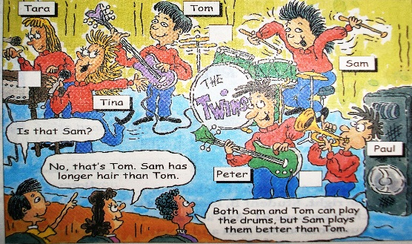

2. Listen and number the pairs of twins in the picture.

Check the answers.

3. Ask Ss to listen to the conversation again and circle the comparatives.

Conversation 1

Boy 1: Is that Sam playing the guitar?

Girl: No, that’s Tom. Sam has longer than Tom.

Boy 2: Both Tom and Sam can play the drums, but Sam plays them better than Tom.

Conversation 2

Boy: That’s Tara, isn’t it?

Girl: No, it isn’t. It’s Tina. Tina is taller than Tara. And she also sings more loudly than Tara.

Conversation 3

Boy: Is that Paul?

Girl: No, that’s Peter. Peter’s heavier than Paul. And Paul’s shorter than Peter.

4. Explanation

both *adj. & pron*.两个；两个都

在句中可作主语、宾语、同位语或定语。

e.g. Both of them are right.

Helen doesn't know which hat is better; she'll buy both.

They both like going camping.

There are some trees on both sides of the river.

【拓展】both ... and ... 意为“ 既…… 又…… ；……和……”，连接两个并列成分。当连接两个并列主语时，谓语动词用复数形式。

e.g. He can both speak and write English.

Both Mike and I are happy.

【语境应用】完成句子

1) 她的两本书都丢了。

_______ _______ books are lost.

2) 他们两个都是美国人。

_______ _______ _______ American.

3) Molly和Cindy都喜爱这部电影。

_______ _______ _______ _______ ________ the movie.

4) 她既会唱歌又会跳舞。

She can _______ sing _______ dance.

5) Mr. Black想要见我们俩。

Mr. Black wanted to see _______ _______.

**IV. Pair work**

1. Practice the conversation in the picture. Then make conversations about the other twins.

A: That’s Tara, isn’t it?

B: No, it isn’t. It’s Tina. Tina is taller than Tara. And she also sings more loudly than Tara.

**V. Summary**

形容词和副词的原级和比较级，即：

原级，也就是原形。

比较级，表示“较……”或“更……”的意思。（用于两者之间比较）

比较级是怎么变化的呢？

形容词或副词的比较级形式：

tall taller

fast faster (一般在词尾 + er )

nice nicer (以字母 e 结尾的 + r )

thin thinner

(重读闭音节词词尾只有一个辅音字母时，先双写辅音字母再加-er)

early earlier

(以辅音字母 + y 结尾的单词，变 y 为 i 加-er )

outgoing more outgoing

(多音节词和部分双音节词前加more)

不规则变化：

|  |  |
| --- | --- |
| **原级** | **比较级** |
| good/well | better |
| bad/badly | worse |
| many/much | more |
| little | less |
| far | farther |
| further |

**VI. Listening**

Work on 2a

1. Ask Ss to complete the chart firstly by themselves.

2. Play the recording and check the answers.

Check the answers.

|  |  |
| --- | --- |
| -er / -ier | more |
| friendly, funny, smart, lazy, fast, high, hard, early | outgoing, hard-working |

3. Listen again and complete the sentences.

* I’m ______________ than Tara. I’m __________ and _______ too. more outgoing, friendlier, funnier
* She can _________ and ___________ than me. run faster, jump higher
* Who’s __________________ at school? more hard-working
* Tina thinks she _____________ than me, but I ______ as ______ as Tina. But she’s _______ than me. works harder, work hard, smarter
* I think I’m ______ than Tara. She always ______________ than me. lazier, gets up earlier

4. Work on 2b

Listen. How are Tina and Tara different?

Tina …

is more outgoing than Tara.

Tara …

works as hard as Tina.

Play the recording again and check the answers.

5. Language points

Tina thinks she works harder than me, but I work as hard as Tina.

as ... as ... “像 / 和……一样……”，两个as中间用形容词或副词的原级。

e.g. The bag is as expensive as that one.

Li Ling sings as well as Lucy.

as ... as ... 的否定形式为not as / so ... as ...，“不像……那样……”。

e.g. My computer is not as / so good as hers.

Tom doesn’t jump as / so high as Jim.

**VII. Pair work**

1. Tell Ss to make their own conversations according to the information in Activity 2c.

Student A, look at the chart on page 18. Student B, look at the chart on page 81. Ask and answer questions about Sam and Tom.

A: Is Tom funnier than Sam?

B: No, he isn’t. Sam is funnier than Tom.

2. Ss practice their conversations.

3. Ask some pairs to act out their conversations.

**VIII. Listen and read**

1. Listen and read the conversation first and try to match the people with the right things.

1. sang better
2. with shorter hair

Nelly

Lisa

1. sang more clearly
2. danced better

2. Let Ss read the conversations after the teacher and learn some new words.

3. Let Ss practice the conversation.

4. Then let some pairs act out the conversation in front of the class.

5. Fill in the blanks.

Anna liked the singing competition. It was ________. Julie thought Lisa, the one with _______ hair, sang ______ and ___________ than Nelly. Anna thought Nelly danced ______ than Lisa. All in all, the _______________ thing is to learn something new and have fun.

6. Language points

1) I think Lisa sang better than Nelly.

better *adj. / adv.*（good和well的比较级）较好的（地）；更好的（地）

e.g. The red bike is better than the blue one.

红色的自行车比蓝色的好。

Mike can play the guitar better than Bob.

迈克弹吉他比鲍勃弹得好。

2) You can tell that Lisa really wanted to win, though.

win *v.* 获胜； 赢；赢得

可以用作不及物动词；

当用作及物动词时，宾语通常是比赛、比赛的名次或奖品、战斗、战争、金钱等。

【语境应用】完成句子

1) Jim _______ _______ _______(赢了比赛) easily.

2) Bill is _______ _______ _______(一定能赢).

3) Who _______ _______ _______(赢得第一名) in the swimming competition?

4) Anna _______ _______ _______(赢得一千元) in the boat race last week.

5) Peter tried his best to _______ _______ _______(赢得一场旅行) to Hawaii.

* though *adv*. 不过；可是；然而

通常用于句末，前面用逗号与句子其他部分隔开

eg It sounds like a lot of fun. Isn't it really dangerous though?

听上去很有趣，可是这不是也很危险吗？

* though *conj*. 虽然；尽管；不过

引导让步状语从句，可与although互换，也可与but引导的分句互相转换

eg They're coming next week, though I don't know which day.

他们下周要来，但我不知道是哪天。

【语境应用】完成句子。

1) 这是件艰难的工作，可是我还是喜欢它。

It's hard work, ____________________.

2) 她虽然累了，但她还是继续跑。

She still kept on running, ____________________________.

3) have fun

have fun“玩得开心”，常用结构have fun doing sth.，“做某事很开心”

=have a good / great time doing sth.

如：I have fun / a good time living with my grandparents.

【语境应用】完成句子。

他们正在开心地打篮球。

 They are ___________________________________________________________.

**IX. Summary**

play the drums

the singing competition

learn something new

have fun

附加疑问句：

That’s Tara, isn’t it?

形容词和副词的比较级和原级：

Tina is taller than Tara.

I think Lisa sang better than Nelly.

as … as

**X. Exercises**

**Ⅰ. 根据句意及所给首字母提示，补全所缺单词。**

1. Sue didn’t want to wake anybody, so she walked into the room q            .

2. She went out, t             it was rainy.

3. I have two dogs and b             are white.

4. Mark has to wear glasses to help him see c            .

5. Frank went on a trip with his family. They had a f             time together.

6. He spoke so l             that all the students in the classroom could hear him.

7. Nelly was a lazy child in the past, but now she is very h             at school.

8. As a result, Class Six w             the basketball game.

**Ⅱ. 根据句意及所给汉语提示，写出所缺内容，每空一词。**

1. Who is _______ _______ _______(敲鼓) now?

2. Lucy sings _______ _______ _______(和……一样好) her mother.

3. We _______ _______(玩得开心) riding our bicycles to the beach yesterday.

4. Mary came first _______ _______ _______ _______(在写作比赛中).

5. I want to take guitar lessons and _______ _______ _______(学一些新东西).

**Homework**

1. Study the grammar on Page 113-115 of Comparative Forms of Adjectives and Adverbs.

2. Write three sentences about the differences between you and your partner.

**Section A 2 (Grammar focus-3c)**

一、**教学目标：**

1. 带学生复习巩固形容词的比较形式及对两者进行对比。

2. 让学生进一步学习两者进行比较的句式结构。

3. 学生能运用所学的目标语言，进行说与写的活动，完成相关任务。

二、**教学重难点**

1. 教学重点：

1) 总结形容词及副词比较级的构成方式。

2) 进一步总结对两者进行比较的句式结构。

2. 教学难点：

1) 总结形容词及副词比较级的构成方式。

2) 能运用所学的目标语言，进行说与写的活动，完成相关任务。

**三、教学过程**

**Learning objective:**

To learn to use comparatives with -er, more and the structure ‘as ... as’

*Is Tom smarter than Sam?*

*Tina is more outgoing than Tara.*

*Are you as friendly as your sister?*

*—Does Tara work as hard as Tina?*

*—Yes, she does.*

**I. Revision**

1. Show the rules to Ss

形容词或副词比较级的构成：

* 一般在词尾 + er
* 以字母e结尾的+r
* 重读闭音节词词尾只有一个辅音字母时，先双写辅音字母再加-er
* 以辅音字母+y结尾的单词，变y 为i加-er
* 多音节词和部分双音节词前加more

不规则变化：

|  |  |
| --- | --- |
| **原级** | **比较级** |
| good/well | better |
| bad/badly | worse |
| many/much | more |
| little | less |
| far | farther |
| further |

2. Ask Ss to look at some pictures and finish the sentences.

**II. Grammar Focus**

1. 学生阅读Grammar Focus中的句子，然后做填空练习。

(1) Tom比Sam聪明吗？

Is Tom _______ _______ Sam?

不是。Sam比Tom更聪明。

No, he isn’t. Sam is ______ _______ Tom.

(2) Tara比Tina更外向吗？

Is Tara _______ ________ ______ Tina？

不是。Tina比Tara更外向。

No, she isn’t. Tina is _______ ________ _______ Tara.

(3) 你和你姐姐一样友善吗？

______ you _______ friendly _______ your sister?

不是。我更友善一些。

No, I’m not. I’m ___________.

(4) Tara与Tina工作一样努力吗?

Does Tara work _______ _______ ______ Tina?

是的。

Yes, she does.

(5) 谁在学校里更努力一些？

Who’s _________ _____________ at school?

Tina认为她学习比我更努力。

Tina thinks she _____ _________ than me.

3. 学生完成填空练习后，可以打开课本检查答案，对错误的句子，单独进行强化记忆。

**Ⅲ. Grammar**

多数形容词和副词有三个等级：原级、比较级和最高级。本节主要学习形容词、副词比较级的用法以及同级比较as…as结构。

**原级**

形容词、副词的原级即原形。

1. 表示两者在某一方面相同

as + 形容词 / 副词原形+ as

e.g. This dress is as beautiful as that one.

Linda sings as well as Amy.

2. 表示一方在某一方面不及另一方时

not as / so + 形容词原形+ as

e.g. Tom isn't as / so tall as me.

I don't sing as / so loudly as my sister.

3. 原级前可用very，quite，too等副词修饰。

e.g. I'm very hungry.

My sister runs quite fast.

It's too hot here.

**比较级**

两者进行比较, 表示“一方比另一方更……”。

1. 标志词：than

e.g. I’m more outgoing than you.

Tom jumps higher than Jack.

3)两者中谁更……

特殊疑问词 + 谓语 + 形容词或副词比较级, A or B?

e.g. Which is better, the red dress or the black dress?

Who dances better, you or your sister?

3. 语境或其他词语暗示了使用比较级

e.g. Are you feeling better today?

Try to do better next time.

5) 形容词和副词的比较级前可以用a little，much，a lot等词语修饰。

e.g. The jacket is a little / much cheaper than the sweater.

Can you speak a lot more loudly?

**Ⅳ. Practice**

Work on 3a

Use the words to write questions and answers.

1) Julie / tall / you

Q: Is Julie as tall as you?

A: No, she isn’t. She’s __________ than me.

2) Jack / run / fast / Sam

Q: ____________________________

A: No, he doesn’t. He runs __________ than Sam.

3) your cousin / outgoing / you

Q: _______________________________

A: No, she isn’t. She is ______________ than me.

4) Paul / funny / Carol

Q: _______________________

A: No, he isn’t. He is _________ than Carol.

1. 读句子，根据提示词完成一般疑问句，并做回答。

2. 看所给的第一例句，让一名学生读例句，确定所有的学生都明白本题的做法。

3. 最后，与学生们一起校对答案，并对学生们有疑问的地方进行解释。

Work on 3b

Think of yourself two years ago. Write about how you are different now.

1. Ask Ss to think of himself/herself two years ago. Write about how they are different now.

2. Give an example:

T: S1, Are you taller now?

S1: Yes, I am. I’m taller than I was two years ago.

T: Pay attention to the tense. “I was two years ago.”

3. Ss work by themselves and write the other four sentences.

4. Check the answers.

**Ⅴ. Group work**

Work on 3c

1. Tell Ss to read the chart first in 3c.

Compare your parents. Check (√) who is smarter, funnier, etc. in the chart. Then ask your partner about his /her parents.

|  |  |  |
| --- | --- | --- |
|  | Mother | Father |
| smart |  |  |
| funny |  |  |
| work hard |  |  |
| outgoing |  |  |
| friendly |  |  |
| sing well |  |  |

2. Example:

A: Who is smarter, your mother or your father？

B: I think my mother is smarter than my father.

3. Ss read the chart and check √ in the chart.

4. Work in groups. Ask and answer the questions with their partners.

5. Try to make a report.

**Ⅵ. 中考链接**

1. My brother Bob is ____ hard-working than me, but I am ____ than him. (2021贵州毕节)

A. most; funnier B. most; funniest

C. more; fun D. more; funnier

2. My brother is much _____ than me now. He grows really fast.

A. tall B. taller

C. tallest D. the tallest

(2021广西河池)

3. Jane has become _____ than before. She can express herself in public now. (2021辽宁朝阳)

A. much outgoing B. most outgoing

C. more outgoing D. less outgoing

4. Guilin isn’t as _____ as Beijing. (2021广西桂林)

A. big B. bigger C. biggest

5. Dr. Yuan Longping had a dream that he could develop rice as _____ as peanuts (花生). (2021湖北黄石)

A. large B. largest C. larger D. the largest

6. I think there’s no need to buy such an expensive coat for a kid. I’d like a ____ one. (2021四川广元)

A. cheap B. cheaper C. cheapest D. lower

7. Credit cards (信用卡) matter a lot _____ than before. We usually pay with smart phones now.

A. little B. fewer C. less D. more

(2021辽宁营口)

8. —Lucy, have you changed a mobile phone with 5G?

—Yes, I think the mobile phone with 5G can send videos much ____ than the one with 4G. (2021湖北鄂州)

A. fast B. fastest C. the fastest D. faster

9. Children usually play this kind of word game _____ than grown-ups. (2021福建)

A. well B. better C. best

**Ⅶ. Exercises**

**Ⅰ. 根据语境及括号内所给单词的提示填空。**

1. —Is here quiet? —Yes, but I know somewhere much _______(quiet).

2. Their house is as _______(big) as mine.

3. The math test was _______(difficult) than the English test. Few students passed (通过) the test.

4. She looks _______(young) than me, but in fact she is much _______(old).

5. Tina didn’t swim as _______(well) as Alice.

**Ⅱ. 根据语境及所给提示词语，完成下列对话。**

1. go there / by car / long / by train

Q: ______________________________?

A: Yes, it does. It takes four hours by car and five hours by train.

2. Sam / early / Molly

Q: ______________________________?

A: No, he didn’t. Molly was a little _______. Sam arrived at about 4:00, but Molly arrived at 3:35.

3. Mark / reach / high / Peter

Q: ______________________________?

A: No, he can’t. Mark isn’t as tall as Peter.

4. who / outgoing / Linda / Cindy

Q: ______________________________?

A: I think Linda is _______ than Cindy. Cindy is very quiet.

5. Tim / play basketball / well / Dave / as

Q: ______________________________?

A: No, he doesn’t. Dave plays basketball _______ than Tim. Tim isn’t interested in basketball at all.

6. you / good / today / yesterday

Q: ______________________________?

A: Yes, I do. Yesterday I felt terrible, but today I feel OK.

**Ⅲ. 根据短文内容及括号内所给汉语提示补全短文。**

Look at Helen and Jenny in the picture. They are my classmates and they are also twin sisters (孪生姐妹). They are both tall, but (1)____________________(Jenny比Helen瘦得多). They both have curly hair, but (2)____________________( Helen的头发看起来长点儿). They like different sports. Helen likes swimming, because (3)____________________(游泳比任何其他运动都有趣) in her eyes. However, Jenny likes running because she thinks (4)____________________(跑步比游泳更有用). At school, (5)____________________( Helen和Jenny一样努力学习). They always get good grades. I am different from them. (6)____________________(我没有他们那么勤奋) so I do badly in my studies. Luckily, they help me a lot and now we are good friends.

**Homework**

1. Compare one of your best friends with you. Write a passage about the same and different things between you two in about 50 words.

2. Preview 1a-1e on page 20.

**Section B 1 (1a-1e)**

一、**教学目标：**

1. 1) 学生能掌握以下单词：talented, truly, care, care about,

2) 能掌握以下句型：

I think a good friend makes me laugh.

For me, a good friend likes to do the same things as me.

Yes, and a good friend is talented in music, too.

That’s not very important for me…

2. 学生在听完对话后能完成相关任务。

3. 让学生了解人与人之间的差异性，明白自己对朋友的看法，明确自己需要什么样的朋友。

二、**教学重难点**

1. 教学重点：

1) 掌握本课时出现的生词及表达方式。

2) 进行听力训练，提高综合听说能力。

2. 教学难点

听力训练

**三、教学过程**

**Learning objectives:**

1. To talk about what kinds of things you think are important in a friend

2. To listen for specific information about Molly’s and Mary’s best friend

**Ⅰ. Revision**

Check the homework. Let some Ss report what his/her father and mother are like.

**II. Thinking and talking**

Work on 1a:

1. Read each description to the class and ask the Ss to repeat.

What kinds of things are important in a friend? Rank the things below 1-7 (1 is most important)

Ask different Ss to copy the six phrases on the Bb. Then read the phrases together.

A good friend …

a. has cool clothes.

b. is talented in music.

c. likes to do the same things as me.

d. is good at sports.

e. truly cares about me.

f. makes me laugh.

g. is a good listener.

2. Read each description loudly. In your opinion, which one is the most important? Please rank the things (1-7). You put a “1” after the thing that is most important to you, and put a “2” after the second most important thing and so forth. Now let’s check which things are most important to you.

Work on 1b:

1. T：Well, every one of you has your own idea. Now please talk about what you think a good friend should be like in groups of four. First read the example dialogue, and then make your dialogue about friends using the phrases in activity 1a.

A: I think a good friend makes me laugh.

B: For me, a good friend likes to do the same things as me.

C: Yes, and a good friend is talented in music, too.

D: That’s not important for me …

Important patterns:

I think …

For me, …

In my eyes, …

I guess…

It’s important for me that…

For me, it is not very important…

I don’t / can’t agree that a good friend…

For me, a good friend…

2. Ss try to write their own sentences.

3. Discuss

Who is your best friend?

Why do you like him/her?

Is she/he different from you in any way?

What do you like about him/her?

**III. Listening**

1. T：Next you will hear an interviewer talking to Molly and Mary. What are they talking about? When I play the recording for the first time, you just listen and give me the answer. Have you got it?

T: They are talking about their best friends. Now look at the chart, and write the things that Molly and Mary like about their best friends. You can write only words and phrases. Let’s check your answers.

2. T: Now let's work on 1d. Let’s listen to the tape again and fill in the rest of the chart in 1c.

3. Ss listen to the tape and fill in the chart.

4. Check the answers:

5. Ask Ss to listen to the conversation again and fill in the blanks.

Interviewer: Who’s your best friend, Molly?

Molly: Peter.

Interviewer: Why do you like him?

Molly: Because he likes to do the same things as I do. He’s _________, too, and he’s

__________ sports.

Interviewer: So, is he different from your in any way?

Molly: Well, yes. I like to study. I study ________ than Peter. He plays baseball ________ than me.

Interviewer: OK, I see…

Molly: Oh, and he speaks ____________ than me. I’m _______________. But I’d say we’re both ________________.

Interviewer: How about you, Mary? Who’s your best friend?

Mary: My best friend is Lisa.

Interviewer: What do you like about her?

Mary: Well, she’s a good _________, and that’s ___________ to me.

Interviewer: Is she a lot like you?

Mary: Some people say we look _________. We’re both ______, and we both have ___________ hair. But Lisa is _________ than me. I’m always talking. She’s also ________. I’m _______________.

**IV. Pair work**

Work on 1e:

Work with your partner. Make a conversation using information in the chart.

Ask several pairs to present their conversations to the class.

**Ⅴ. Language points**

1. …is talented in music.

在音乐方面有天赋。

talented *adj*. 有才能的；有才干的

常在句中作定语或表语。其比较级为more talented。

be talented in… 在……有才能

e.g. 我的好朋友很有音乐才能。(翻译)

My best friend is talented in music.

【助记】

talent (名词 天资；天才)+ -ed (形容词后缀)→ talented (形容词 有才能的)

2. …truly cares about me. 确实关心我。

truly *adv*. 真正；确实

常位于连系动词be、情态动词或助动词之后，实义动词之前。

e.g. She is truly talented in sports.

她确实有运动天赋。

Jack truly studies hard.

杰克学习确实努力。

辨析true, truly, truth

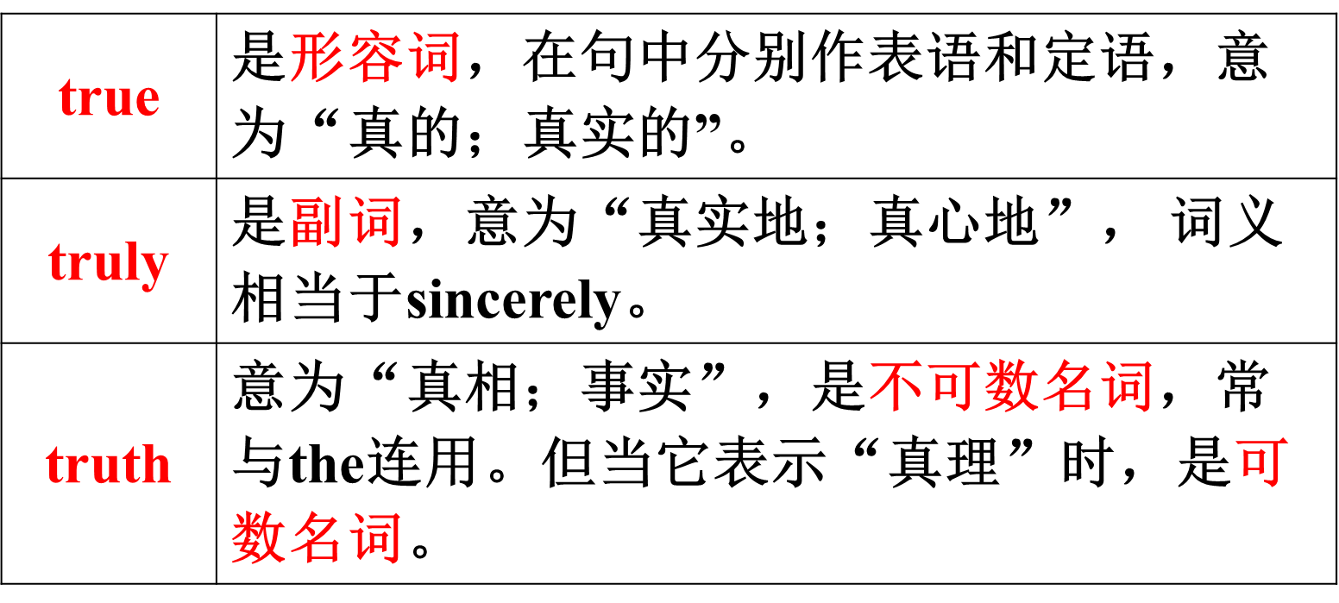

【语境应用】根据句意，用true, truly或truth填空。

1) I am ______ grateful for all your help.

2) I don’t believe the ______ of that story.

3) Is it ______ that Martin and Sue are getting married?

Keys: 1) truly 2) truth 3) true

care *v*. 在意；担忧；关心

care about 关心；在意

e.g. She felt that nobody cared.

她觉得没有人在意。

Your mother truly cares about you.

你妈妈确实关心你。

care *n*. 小心；注意；关怀

take care (=be careful) 当心，小心

take care of (=look after) 照顾，照看

e.g. Take care not to fall into the river.

当心不要掉进河里。

You should take care of yourself.

你应该照顾自己。

3. …makes me laugh. ……让我笑

make sb. do sth. 让某人做某事

注：使役动词make / have / let后要跟省略to的动词不定式作宾语补足语。

e.g. His father always makes him get up before six o’clock.

他爸爸总是让他在六点钟之前起来。

The teacher made me answer this difficult question.

老师让我回答这个难题。

拓展

(1) make sb./ sth. +形容词 让某人/某物……

该结构中的形容词作宾语补足语。

e.g. You should make your parents happy.

你应该让你父母开心。

(2) make sb. +名词 让某人成为……

该结构中的名词作宾语补足语。

e.g. They made Jack their team leader.

他们选杰克当他们的队长。

laugh *vi*. 笑；发笑

laugh at ①嘲笑；②因……发笑

e.g. He laughed, and told me not to do it again.

他笑了，告诉我不要再那样做了。

We shouldn’t laugh at others when they are in trouble.

当别人陷入困境时，我们不应该嘲笑他们。

*n*. (可数名词) 笑声

break into a loud laugh 突然大笑起来

e.g. He gave a short laugh. 他笑了一声。

辨析laugh与smile

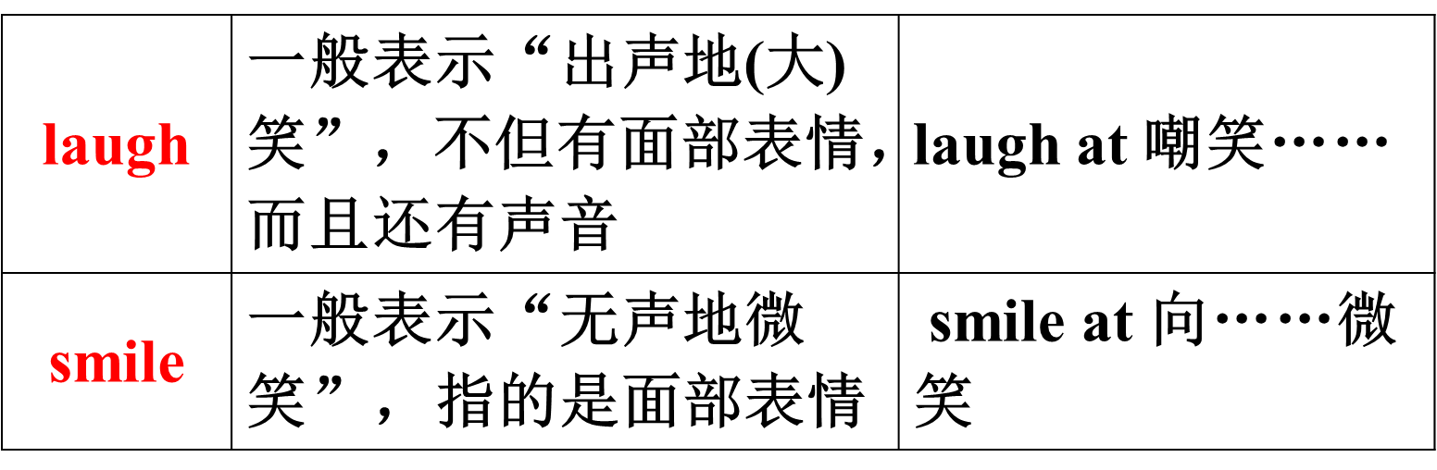

【语境应用】完成句子。

1) 嘲笑陷入麻烦的人不好。

It isn’t good to _______ _______ a person in trouble.

2) John突然大笑起来，然后说：“Mary总是这么有趣。”

John _______ _______ _______ _______ _______ and said, “Mary is always so funny.”

3) Tom听了我的笑话没有发笑。

Tom didn't _______ _______ my jokes.

Keys: 1) laugh at 2) broke into a loud laugh 3) laugh at

**Ⅵ. Summary**

be talented in

the same as

care about

a good listener

be good at (doing) sth.

make sb. do sth.

A good friend likes to do the same things as me.

I like to have friends who are different from me.

**Ⅶ. Exercises**

根据汉语意思，完成英语句子，每空一词。

1. Mrs. White真的很关心她班里的学生。

Mrs. White really _______ _______ the students in her class.

2. 那个女孩在数学方面有天赋。

The girl _______ _______ _______ math.

3. 是什么原因让你说出那种话来？

What _________ you _________ that?

4. 她是一个很好的倾听者。

She is a very ___________ ___________.

**VIII. Homework**

Write about you and your best friend …

What do you like about him/her?

The same things between you.

The differences between you.

**Section B 2 (2a-2e)**

一、**教学目标：**

1.1) 学生能够掌握以下单词：serious, mirror, kid, as long as, necessary, be different from, both, though, bring out, grade, should, the same as, saying, reach, hand, touch, heart, fact, in fact, break, arm, share

2) 能掌握以下句型：

You don’t need a lot of them as long as they are good.

Larry is quite different from me.

My best friend is similar to Larry because she’s less hard-working than me.

I always get better grades than he does...

2. 学生在阅读短文后能完成相关任务。

3. 让学生在学完篇章后了解人与人之间的差异性，了解自己对朋友的看法，明确自己需要什么样的朋友。

二、**教学重难点**

1. 教学重点：

1) 掌握本课时出现的生词及表达方式。

2) 阅读短文，获得相关信息，提高学生们的综合阅读能力。

2. 教学难点

阅读2b部分的短文并完成相关任务。

**三、教学过程**

**Learning objectives:**

1. To understand the passages about three pairs of good friends’ similarities and differences

2. To learn to compare your friends, using comparative forms

3. To learn some new words and useful expressions

4. To understand the attitudes and views of Chinese and foreign adolescents towards friendship

**Ⅰ. Revision**

Check the homework. Let some Ss report what his/her friends are like.

**Ⅱ. Warming up**

Show the picture of two boys to lead to the passage learning.

**Ⅲ. Pre-reading**

Work on 2a, 2b

1. T: Write the comparative forms of the following adjectives. Then use them to write five sentences about you and your friends.

2. Ss work in a group. Check each other’s answers.

3. Let some Ss read their sentences.

4. T: Listen and read the passages about what three people think about friends and find

the comparative words and phrases in the passages.

**Ⅳ. Reading**

Pre-reading

Write the comparative forms of the following adjectives. Then use them to write five sentences about you and your friends.

popular ____________ funny ________

hard-working ___________________

quiet ________ serious _____________

friendly _________ smart _________

outgoing _____________ shy _______

e.g. My friend David is more hard-working than me, but I am funnier than him.

Read the passage and try to answer the question:

Should friends be the same or different?

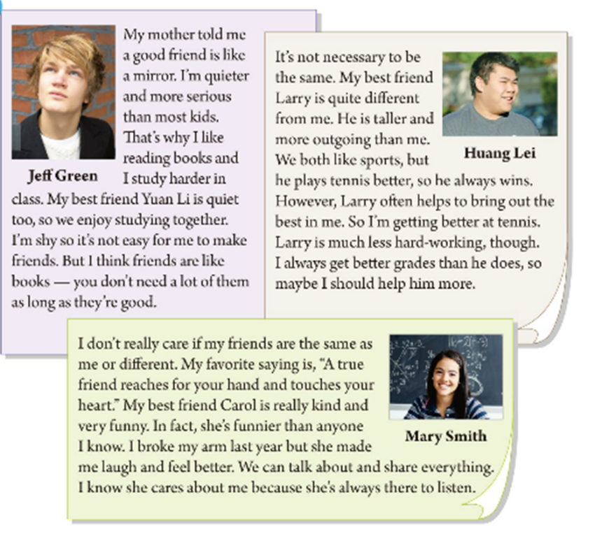

Fast reading

T: What do the three people think of their friends? Now read the passages and match the

person with the right ideas.

Read the passage quickly and find his/her friend.

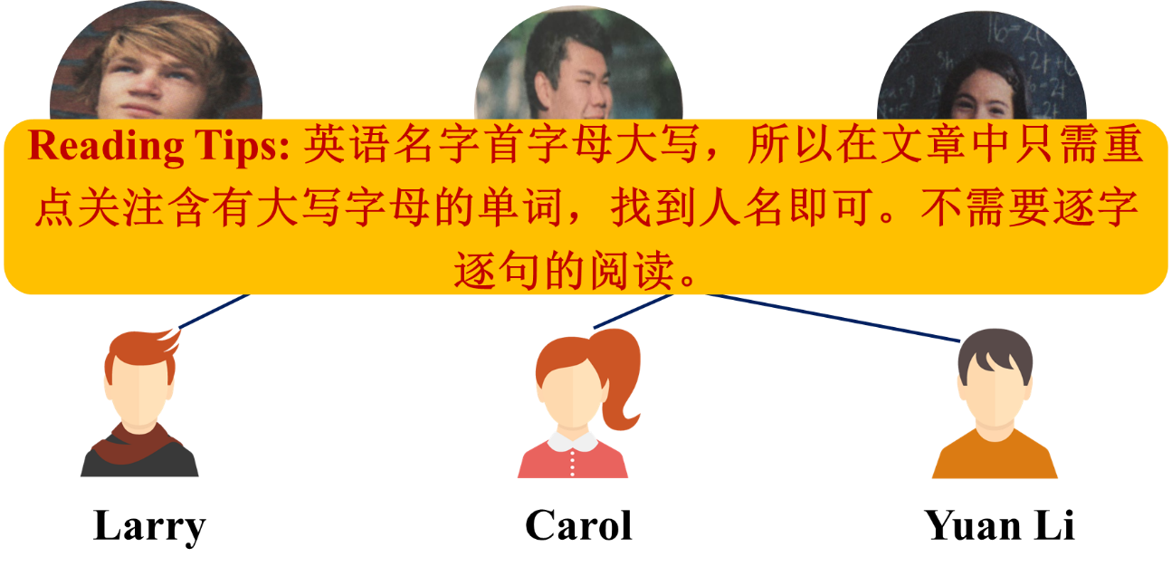

Careful reading

1. Let Ss read the Jeff's story and answer the question.

What's Jeff's opinion about a friend?

Reading Tips: 此题是考查态度问题，需重点关注文章的首、末两句。

议论文要注意观察转折词后的单词或句子。



My mother told me a good friend is like a mirror. I'm quieter and more serious than most kids. That's why I like reading books and I study harder in class. My best friend Yuan Li is quiet too, so we enjoy studying together. I'm shy so it's not easy for me to make friends. But I think friends are like books.—you don't need a lot of them as long as they're good.

1. What is Jeff 's opinion about friend?

Friends are like books―you don't need a lot of them as long as they're good.

2. Does Jeff have a lot of friends? Why or why not?

No, he doesn't. Because he is shy. It's not easy for him to make friends.

A good friend is like a mirror.

Friends are like books―you don't need a lot of them as long as they're good

Read the Huang Lei's story and answer the question.

What's Huang Lei's opinion about a friend?



How could they become best friends?

It's not necessary to be the same. My best friend Larry is quite different from me. He is taller and more outgoing than me. We both like sports, but he plays tennis better, so he always wins. However, Larry often helps to bring out the best in me. So I'm getting better at tennis. Larry is much less hard-working, though. I always get better grades than he does, so maybe I should help him more.

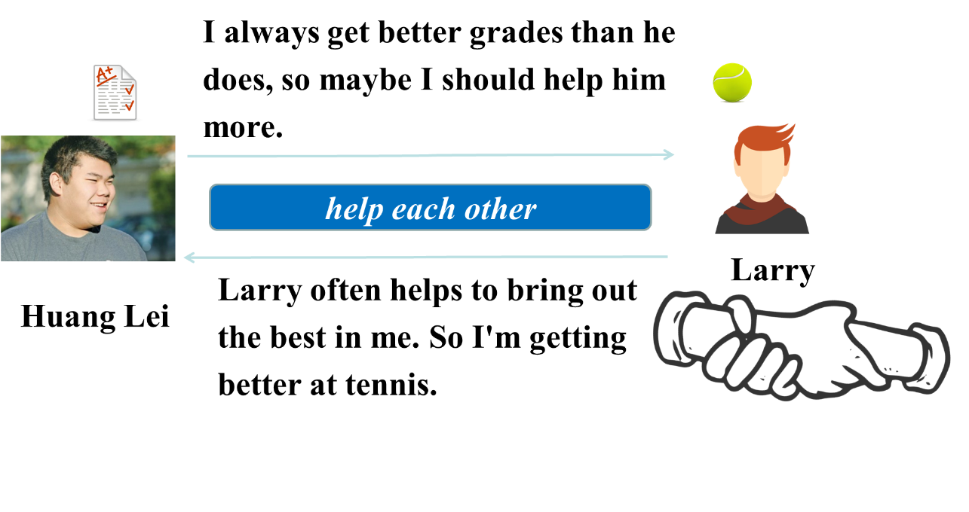

A friend often helps me to bring out the best in me.

真正的朋友能够帮我激发出自己的所能。

A friend in need is a friend indeed. 患难见真情。



I don't really care if my friends are the same as me or different. My favourite saying is,” A true friend reaches for your hand and touches your heart.” My best friend Carol is really kind and very funny. In fact, she's funnier than anyone I know. I broke my arm last year but she made me laugh and feel better. We can talk about and share everything. I know she cares about me because she's always there to listen.

What's his/her opinion about a friend?

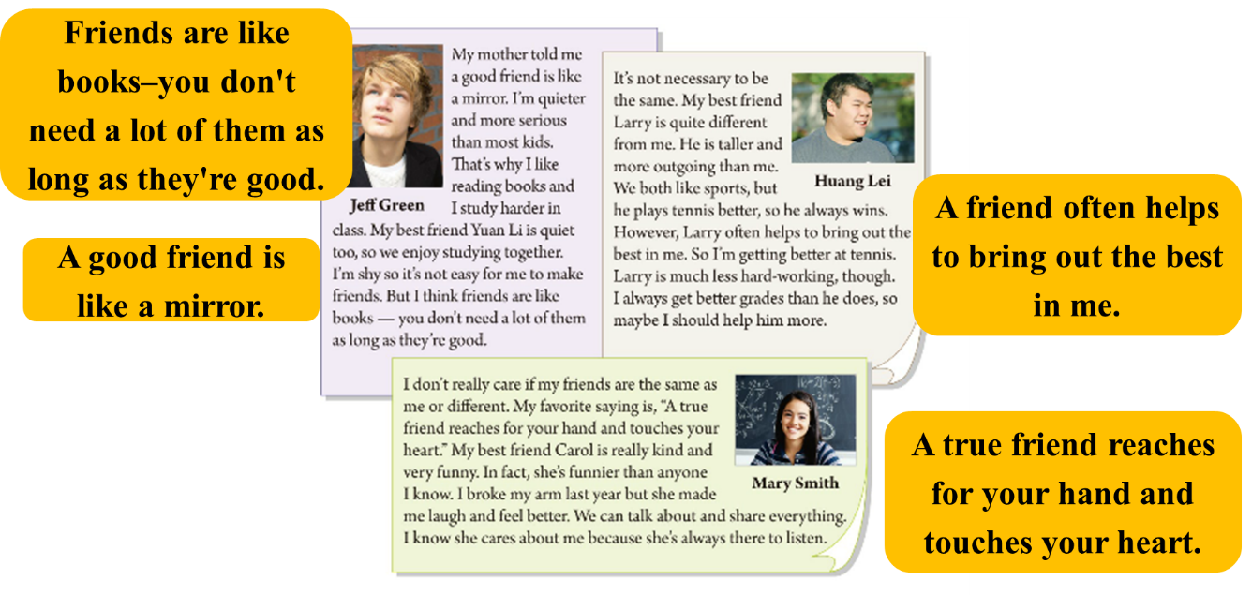

3. Let Ss complete the table according to the passage.

|  |  |  |
| --- | --- | --- |
|  | Similarities  (相似之处) | Differences |
| Jeff Green and Yuan Li | ◆They are both _____.  ◆They both enjoy  studying together. | ◆Jeff is more serious.  ◆Jeff ______________ in class. |
| Huang Lei and  Larry | They both like  _______. | ◆Larry is _______ and more  outgoing.  ◆Larry _____________ better.  ◆Larry is much less  hard-working. |
| Mary Smith and  Carol | \ | Carol is funnier. |

4. Let Ss read the passages again and judge these sentences True or False on 2c.

Post reading

Fill in the blanks.

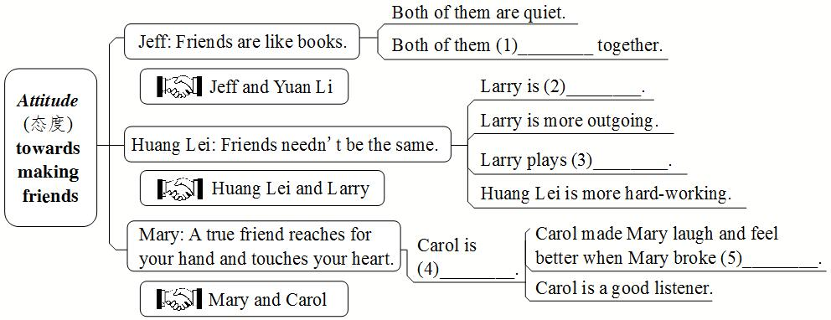

2. Group work.

Try to retell their opinions.

What’s Jeff Green’s opinion? What are the similarities and differences between him and his friend?

What’s Huang Lei’s opinion? What are the similarities and differences between him and his friend?

What’s Mary Smith’s opinion? What are the similarities and differences between her and her friend?

**Ⅴ. Writing**

1. T: Now let’s think of you and your friends. How do you and your friends compare with the people in the article? Write five sentences.

方法指导：首先，应思考一下自己及自己朋友的特点；然后，认真与短文所提及的人物进行对比。写出明确的比较句。注意运用正确的比较句：

句型指导：

A + be different from B because + 两者比较句

A + be similar to B because + 两者比较句

3. Ss try to write their sentences.

4. Let some Ss read aloud their sentences to the class.

**Ⅵ. Language points**

1. That’s why I like reading books and I study harder in class.

这就是我喜欢看书而且在班上学习更努力 的原因。

That’s why… 这便是为什么……，这就是……的原因。why后接结果，why引导的句子作表语，是表语从句。

e.g. I got up late, and that’s why I missed the bus.

我起晚了，这就是我没赶上公共汽车的原因。

拓展

That’s because… 这是因为……。Because后接原因。

e.g. That’s because she is not old enough.

这是因为她年龄不够大。

2. I’m shy so it’s not easy for me to make friends.

我很腼腆，因此对我来说交朋友不容易。

It’s + *adj*.+for sb. to do sth. 对某人来说，做某事是……的。另一固定句式为 It’s + *adj*. + of sb. to do sth. 某人做某事是……的。两个句中的it都是形式主语，真正的主语是后面的动词不定式结构。

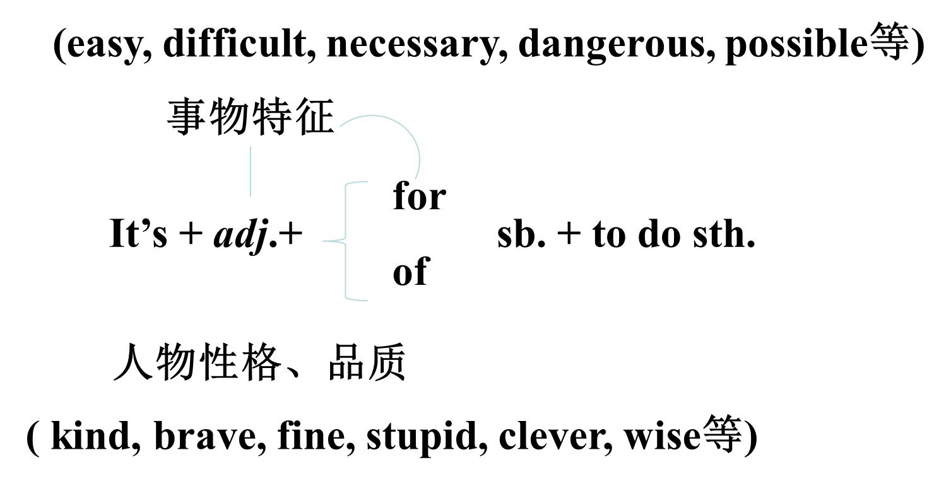

e.g. It’s dangerous for a child to stay at home alone.

对一个孩子来说，自己一个人待在家里是很危险的。

It’s very nice of you to lend an umbrella to me.

你把雨伞借给我，真是太好了。

【语境应用】单项选择。

It’s necessary __________ masks (口罩) in public places during the COVID-19 period.

A. for us to wear B. for us wearing

C. of us wearing D. of us to wear

(2020云南中考)

Key: A

3. …you don’t need a lot of them as long as they’re good.

……不在多而贵在好。

as long as 只要…… 引导条件状语从句

主句为一般将来时或主句谓语含有情态动词can时，as long as所引导的条件状语从句用一般现在时表示将来。

e.g. We’ll go as long as the weather is good.

只要天气好我们就去。

You can leave here as long as you tell the truth.

你只要说出真相，就可以离开这里。

as long as 既然；和……一样长，达……之久

e.g. As long as you are going, I’ll go.

既然你要去，那么我也去。

The river is as long as that one.

这条河和那条河一样长。

You can stay for as long as you want.

你想待多久就待多久。

【语境应用】单项选择。

1) We can get over the trouble _______ we depend on our own country.

A. as much as B. as far as C. as soon as D. as long as

(2021辽宁营口中考)

2) __________ we continue to pull together, we'll keep winning the game.

A. As long as B. Even though C. As soon as

(2021四川成都中考)

Keys: 1) D 2) A

4. It’s not necessary to be the same.

(和朋友)一样是没有必要的。

necessary *adj.* 必需的；必要的

necessary 不能修饰或描述人，只能修饰或描述事物，常用于“It’s (not) necessary to do sth. ”句型中。

e.g. Sleep is necessary for health. 睡眠是健康所必需的。

It’s necessary to brush your teeth at least twice a day.

每天至少刷两遍牙是有必要的。

It’s not necessary to do this every day.

没必要每天这样做。

5. However, Larry often helps to bring out the best in me.

然而，拉里经常(能够)帮我激发出自己的所能。

bring out 使显现；使表现出

bring out the best/worst in someone 把某人最好（或最坏） 的一面展现出来

e.g. I want to bring out the meaning of the poem.

我想阐明一下这首诗的意义。

Please tell me how to bring out the best in me.

请告诉我怎样把我最好的一面展现出来。

【语境应用】单项选择。

1) Pan Jianwei has become a famous scientist. When he was a child, he liked to __________how things worked,

A. set out B. find out C. leave out D. bring out

(2021山东滨州中考)

2) —Larry has changed a lot since he had a baby.

—Yeah. Being a parent has _____ all his love and sense of duty.

A. taken up B. brought out C. made up D. given out

(2021湖北武汉)

Keys: 1) D 2) B

6. I always get better grades than he does, so maybe I should help him more.

我总是比他取得更好的成绩，因此也许我应该更多地帮助他。

句中的he does相当于he gets grades。英语中，为了避免重复，可以用助动词do / does / did ...代替前面刚提到的动词(短语)。

该句还可以写成 I always get better grades than he / him ...

【语境应用】用do, does或 did填空。

1) John works much harder than he ___________ last year.

2) Lucas plays chess better than his brother ___________.

3) My sister always drinks coffee with sugar, but I never ___________.

Keys: 1) did 2) does 3) do

should *modal v.* 应该；应当；可以

否定式为shouldn’t，其后接动词原形，无人称和数的变化。常用来表示建议、劝告、要求、义务或征询意见等。

e.g. You should care about your parents.

你应该关心你的父母。

We shouldn’t break the rules.

我们不应该违反规则。

What should we do now?

我们现在该做什么？

【语境应用】单项选择。

—Only ten tickets? What do you mean? There _______ be twelve.

—Sorry, Linda. Jacky and Tim took two tickets away.

A. should B. will C. can D. may

(2021湖北武汉)

Key: A

7. I don’t really care if my friends are the same as me or different.

我并不十分在乎我的朋友跟我一样还是与我不同。

if *conj*. 是否 引导宾语从句

e.g. Can you tell me if he can play the drums?

你能告诉我他是否会敲鼓吗？

if *conj*. 如果 引导条件状语从句。在含有if引导的条件状语从句的主从复合句中，若主句为一般将来时，从句用一般现在时表将来，即“主将从现”。

e.g. I won’t go there with you if it rains tomorrow.

如果明天下雨，我将不和你们一起去那里。

【语境应用】单项选择。

– Let’s go camping if it ________ next Saturday.

– But nobody knows if it ________.

A. is fine; rains B. will be fine; rains

C. is fine; will rain D. will be fine; will rain

(2020四川乐山)

Key: C

8. A true friend reaches for your hand and touches your heart.

一个真正的朋友在需要时给你帮助，使你感动。

reach *v*. 伸手

reach for ... 伸手去拿……，够到……

e.g. A man stood up to reach for something in the overhead shelf.

一名男子起身去拿头顶上方柜子里的什么东西。

*v*. 到达；抵达 后面直接跟地点名词或表示地点的副词

e.g. I will call you as soon as I reach Kunming/there.

我一到昆明/那儿就给你打电话。

辨析 reach, arrive与get

三者都可表示“到达”，但用法不同，具体如下：

(1) reach作及物动词，其后直接跟表示地点的名词。

e.g. I reached Qingdao yesterday. 我昨天到了青岛。

(2) arrive和get都是不及物动词，其后可以跟表示地点的副词(here, there, home等)，跟地点名词时须加介词，即“arrive in+表示大地点的名词(如国家、城市等) ”“arrive at +表示小地点的名词(如村庄、商店等) ”“get to +地点名词(大小地点都可)”

e.g. How did you arrive / get there?

你是怎么到那儿的？

I arrived in/ got to Qingdao yesterday.

我昨天到了青岛。

When do you often arrive at/ get to the village?

你经常什么时候到那个村庄？

【语境应用】完成句子。

1) Uncle Wang _______________________________ (到达北京) at 3:00 p.m. yesterday.

2) The old man tried to __________________________ (伸手去拿电话) and call his son.

Keys: 1) reached / got to / arrived in Beijing 2) reach for the phone

touch *v*. 感动；触摸

touch one’s heart 触动某人的心弦

e.g. “Don’t touch the dog!” she shouted.

“不要碰那只狗！”她大叫。

I love this song. It can touch my heart.

我喜欢这首歌，它能触动我的心弦。

touch *n*. 触觉；接触

keep / stay in touch (with sb.) (与某人)保持联系

get in touch 取得联系

e.g. Nowadays, we can move around the world and still stay in touch with our friends.

如今，我们能游走全世界，且仍然能与我们的朋友保持联系。

【语境应用】根据所讲内容将下列汉语句子翻译成英语。

1) 不要用脏手摸你的脸!

__________________________________________________

2) 我和很多老朋友失去了联系。

__________________________________________________

3) 我今天下午试图与李明取得联系。

__________________________________________________

Keys: 1) Don’t touch your face with dirty hands!

2) I lost touch with many old friends.

3) I tried to get in touch with Li Ming this afternoon.

9. I broke my arm last year but she made me laugh and feel better.

去年我摔断了胳膊，但她逗我开怀大笑，并让我感觉好起来。

break *v*. (使) 破；裂；碎；损坏

*n*. 休息

【归纳】break短语

break the rule  违反规则

break off   突然中止；中断

break down   停止运转；出故障

have a break (课间)休息一下

【语境应用】翻译/ 完成句子。

1) 我昨天打碎了一个碗。

2) 孩子们有课间休息。

3) Dave is a good boy. He never ______________________ (违反校规).

4) My TV set ____________ (出故障) last night, so I didn’t watch the game.

5) One of the plane’s wings __________ (中断) and it crashed into the ground.

Keys: 1) I broke a bowl yesterday.

2) The children have a break between classes.

3) breaks the school rules

4) broke down

5) broke off

10. My best friend is similar to Larry …

我最好的朋友与拉里相似……

similar *adj.* 相似的；相仿的

【归纳】

be similar to 与……相似/相仿

be similar in 在某方面相似/相仿

e.g. Your views on education are similar to Mr Wang’s.

你对教育的看法和王先生相似。

The two cars are similar only in color.

这两辆车只有颜色相似。

【语境应用】根据句意，用恰当的介词填空。

1) Your views on education are similar ________ Mr Wang’s.

2) The two cars are similar only ________ color.

Keys: 1) to 2) in

**VII. Exercises**

Ⅰ. 根据句意及所给汉语提示，写出所缺单词。

1.“A friend in need is a friend indeed.” This is one of my favorite _______(谚语).

2. The little boy dislikes _______(分享) his model planes with others.

3. Rick _______(摔断) his arm when he went skating yesterday.

4. The police ______________________(到达) here just now.

5. Remember to keep both _______(手) clean and wash them before eating.

6. Henry’s story _________________(感动) me deeply (深深地) and I wanted to do something to help him.

7. Follow your _______(内心) and go for it. Then you will enjoy your life.

Ⅱ. 根据汉语意思，完成英语句子，每空一词。

1. 他总能激发出他学生的潜能。

He can always ______ ______ ______ ______ in his students.

2. 她看上去很严肃，但实际上不是。

She seems serious, but _______ _______ she isn’t.

3. 今晚你可以出去，只要你按时到家。

You can go out this evening _______ _______ _______ you get home on time.

4. 他的品味和我的不同。

His taste _______ _______ _______ mine.

5. 我的房子和她的房子在大小上相似。

My house _______ _______ _______ hers in size.

6. 他随时都能回答你的问题。

He _______ _______ _______ _______ answer your questions.

7. Frank没有变，他看起来和以前一样。

Frank hasn’t changed. He looks just ______ _______ _______ before.

**VIII. Homework**

Write a short passage about ‘Should friends be the same or different?’.

**Section B 3 (3a-Self check)**

一、**教学目标：**

1. 学生能够掌握下列词汇：primary, primary school, information

2. 带学生一起复习如何对两者进行比较，并且能够综合运用所学的知识来对两个事物或人物进行对比。

3. 学生能够学会写描述人的短文。

4. 学生能了解人与人之间的差异性，做到相互理解相互学习。

5. 帮助学生正确看待自己和他人的优缺点，学人之长，补己之短。

二、**教学重难点**

1. 教学重点：

1) 能运用所学的知识对事物或人物进行对比。

2) 写描述人的短文。

2. 教学难点：

写描述人的短文

**三、教学过程**

**Learning objectives:**

1. To learn to describe and compare two of your friends.

2. To learn to write a passage describing people.

**Ⅰ. Revision**

Ask some Ss to introduce Jeff Green, Huang Lei and Mary Smith.

**Ⅱ. Pre-writing**

1. work on 3a.

2. 写作指导：

阅读表格中的描述；分析描述词的特点；是用形容词还是用动词进行描述；根据在导入总结的句式结构来对学生们进行描述。相似的地方，可以用both来共同表达出来；不同的地方，可以用比较的句式表达出来。

3. Ss try to write these sentences.

4. Check the answers.

**Ⅲ. Writing**

Work on 3b:

1. Think of your friends. Make notes about two of your friends. One friend should be similar to you. The other friend should be different.

|  |  |
| --- | --- |
| **A friend who is similar to me** | **A friend who is different from me** |
| Name: | Name: |
|  |  |

2. Give some examples: popular, outgoing, serious, hard-working, tall, thin … likes reading/sports, art, music… has long/short straight hair …

3. Check the answers with each other.

Work on 3c:

Write two paragraphs describing your friends.

【审清题目】

内容：介绍你的两位朋友(一位与你相似，一位与你不同)。

文体：描写性质的文体。

时态：描述人物现在的情况，用一般现在时。

人称：描述他人时，用第三人称。

【头脑风暴】

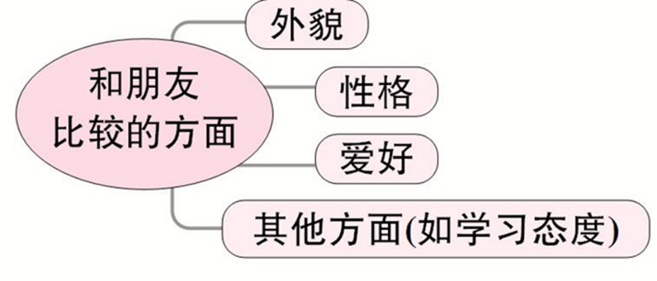

【提供素材】

◆语块

1. 外貌：tall, thin, heavy, strong, of medium height, short straight hair, long curly hair, big eyes, wear glasses

2. 性格：outgoing, shy, quiet, funny, serious, smart, clever, friendly, kind (友好的), honest (诚实的), brave (勇敢的)

3. 爱好：playing basketball / football / tennis / volleyball ..., swimming, reading, writing, dancing, singing, playing chess, playing the piano / violin ..., be interested / talented in

4. 学习态度：hard-working, careful, careless (粗心的)

◆句型

1. We are similar to each other in many ways.

2. Both of us like ...

3. We are different from each other in ...

4. She / He is more / less ... than me.

5. She / He likes to do the same things as me.

6. She / He is / likes ..., but I am not / don’t like ...

7. I’m as ... as ...

◆谚语

Better without gold than without friends.

(宁可没有金钱，不可没有朋友。)

A friend in need is a friend indeed.

Good friends are like stars. You don’t always see them, but you know they’re always there.

Sample

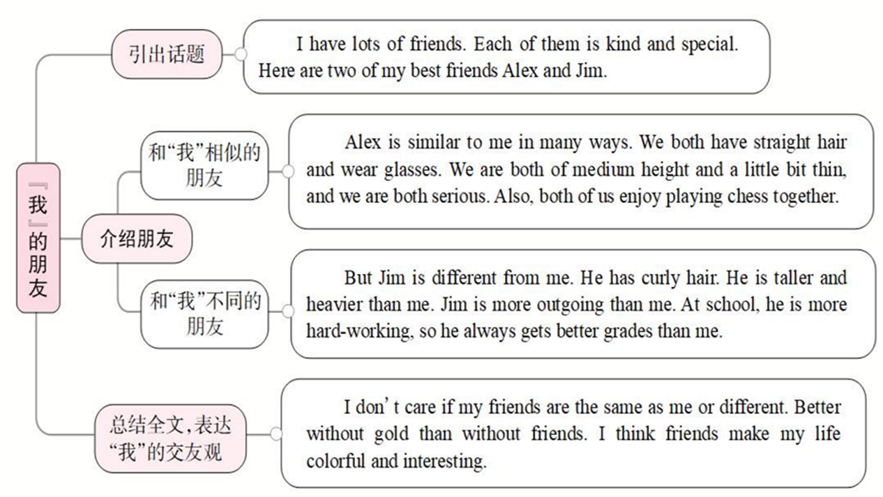

**Ⅳ. Practice**

1. Ask the questions about the ad.

① What job is the ad for?

② What does the English Study Center need the weekend helper for?

③ What kind of person is good for this job?

2. Let Ss read the ad and answer the questions.

3. Let Ss think about what the student should be like?

Give Ss some examples:

He/She should be outgoing. He/She should be good with children. He/She should be good at English …

4. Ask Ss to compare two of their classmates. They can use the real names.

**Ⅴ. Self Check**

**Work on Self Check 1**

1. Look at the chart. Let one student read the words in the box first.

|  |
| --- |
| hard-working, run fast, quiet, serious, jump high, smart |

|  |  |
| --- | --- |
| What people are like | What people can do |
|  |  |

2. Tell Ss to put the words in the correct columns in the chart. Make they know they should put some adjectives in the first column. In the second column, they should put some “verbs + 副词”。

3. Ss work by themselves and then check the answers with the Ss.

**VI. Summary**

primary school

be good with

a middle school student

have good grades in English

**Ⅶ. Exercises**

Ⅰ. 根据句意及括号内所给单词的提示填空。

1. Julia says she is feeling a lot _________ (well) today.

2. Our new schoolbags look similar, but yours is much _________(expensive) than mine. 3. My father says I don't write as _________ (carefully) as I did last term.

4. Mary is _________(friendly) than me, and she is always there to help others, so she is _________(popular) at school.

5. My father is getting a little _________ (fat) than he was five years ago.

Ⅱ. 根据短文内容，从方框中选择恰当的单词填空，注意形式变化。

well, fact, decide, saying, serious, care, true, touch, hard-working, different

Amazing China (《厉害了，我的国》) is a 90-minute documentary (纪录片) about the development (发展) of China. It tells us how the (1)______ Chinese people work together and make our dream come true. Many students go to the cinema to see it, though it is a (2)______ movie, not a funny one. These days young men really (3)______ about our country. I think it’s (4)______ necessary for all the students to watch the movie because it helps them to know China (5)______. I asked some students who had seen the movie how they liked it. Here are their answers.

Li Zhenyu, 14, from Xi’an, said, “It was a great movie. The stories in the movie (6)______ my heart. From then on, I (7)______ to work harder than before.”

Zhang Cheng, 15, from Beijing, said, “The movie shows that China progressed (进步) quickly in (8)______ ways. I’m proud (骄傲的) to be Chinese.”

Song Qingqing, 18, from Shanghai, said, “I remembered an old (9)______: Where there is a will, there is a way. In (10)______, I’m sure we Chinese people all work hard to make China a greater country in the future.”

**VIII. Homework**

想一想你的好朋友与你在什么地方相似，在哪些地方不同。请用英语写出三条相似之处与三条不同之处。